**Maze Wars - User Guide**

**Group Members: Cathy Tung, Joffrey, Tito Babatunde, Mohammadkazem Meidani, Pouya Hemmasian**

1. **Game rules**

* In this game, two tanks move and rotate in a maze and shoot bullets to destroy the other tank in the maze. Fig 1. Illustrates the explosion of one of the tanks.
* Each player has a tank which starts from a random location inside the randomly generated maze. The players play until a bullet of one of the player’s tanks hits the other tank. In this game, the bullet does not affect the shooter itself.
* Each time a tank is destroyed, the other player receives a **+1 score** and the game restarts in a new randomized maze and new starting positions.
* The first player who can reach the **score of 3**, i.e., can destroy the other player’s tank 3 times, **wins** the game.

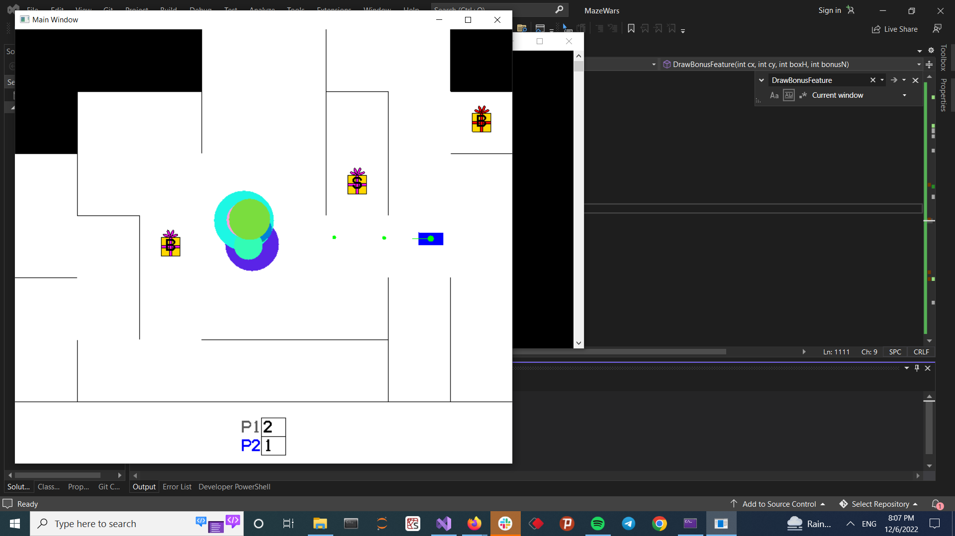

Fig. 1: Visualization of Player 1 tank explosion from Player 2 shooting.

1. **Game Menu**

* The menu shows the tanks of the two players with different colors.
* Each of the tanks follow a set of keys to move and rotate in the game environment. The keys are:
  + Move Up
  + Move Down
  + Rotate Right
  + Rotate Left
* Fig 2. Illustrates and describes how the users can select their favorite keys in the game menu before starting the game.

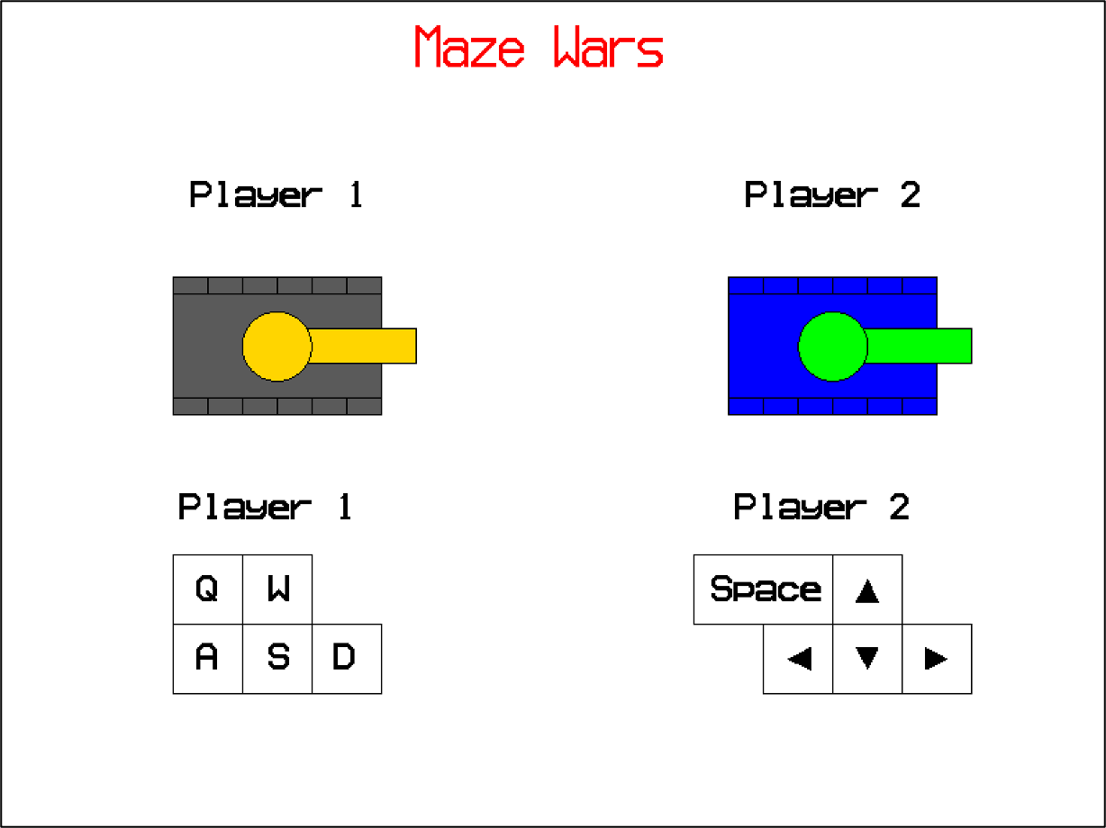

Fig. 2: Keys used on keyword (From Game Menu). Player 1 first selects which set of keys they want to use, then the main menu waits for Player 2 to select the other set of keys. After a couple of seconds, the main menu window is replaced with the game window.

1. **Game Environment**

* When each game starts, a random maze is generated where the **white cells** show active cells where the tanks can move, and black cells which are blocked and unavailable for the tanks. The tanks start from a random location in available cells, and have some minimum distance from each other at the beginning of the game.
* When a tank shoots, the bullets appear for a limited time after shooting, and they will fade after a few seconds. The maze has several walls that hinder the bullets and the bullet rebounds after hitting them. Therefore, one player can hit the other tank without the need for a direct line shot.

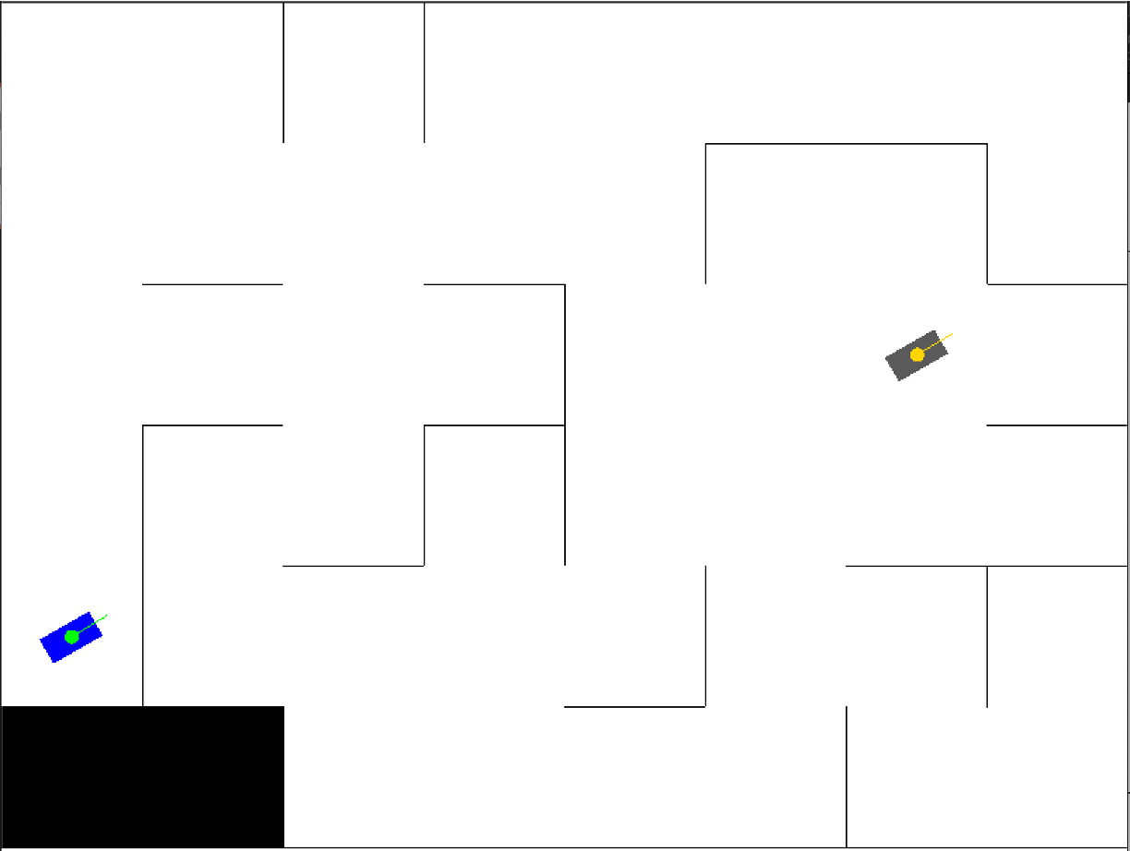

Fig. 3: A scheme of the game environment at the beginning of the game. The maze is randomly generated and the tanks are located in random cells far from each other.

* There are several bonus items randomly located in the maze. Each tank can attain the bonus feature by moving over the item. The items are as follows:
  + Item 1:

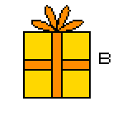

* + Item 2:

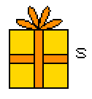

* + Item 3:

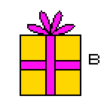

* + Item 4:

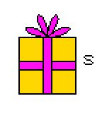

* + Item 5:

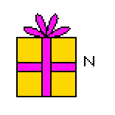

1. **How to Play**

* As described in the game menu, players can move into the forward and backward directions, and rotate clockwise or counterclockwise. Also, players can shoot bullets (only up to 5 bullets from a tank can be in the game simultaneously). The keys for these actions are as follows for the two sets of keywords:
  + Move Forward: **Up arrow** or **W**
  + Move Backward: **Down arrow** or **S**
  + Rotate Clockwise: **Right arrow** or **D**
  + Rotate Counterclockwise: **Left arrow** or **A**
  + Shoot a bullet: **Space** or **Q**

1. **Features**

In addition to the game play, and the game rules, there are some features that are used in this program. We explain some of these features.

* The scoreboard shows the scores achieved by the players during the game. This helps the players to see how close they are to the end. When a player first reaches the score 3, they win the game.
* As soon as the game ends, the results screen is displayed where the winner of the game is announced.

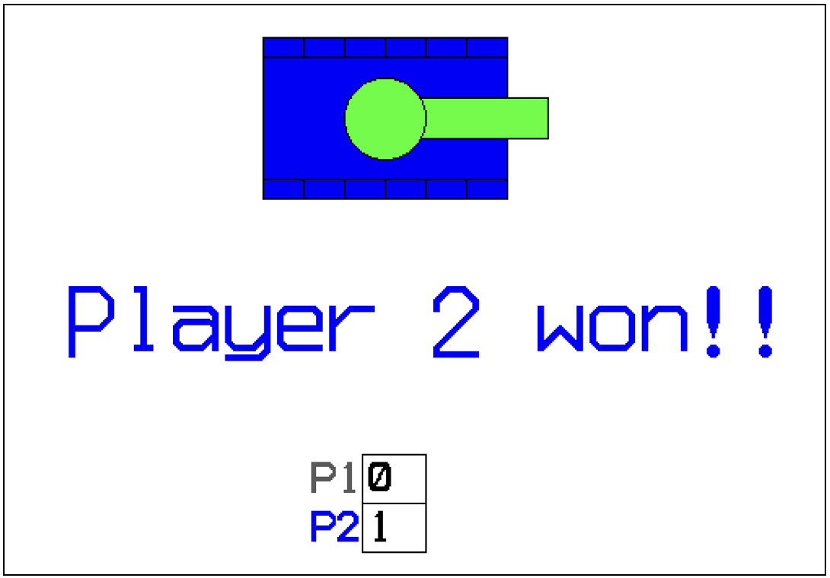

Fig. 4: The final screen that is shown after the game ends and announces the winner with the same color of their tank along with the scoreboard showing the scores achieved by each player.